Why You Need These 5 Tactical Tips To Survive A Home Invasion
Lucky for you, there are steps you can take to not only be prepared for a home invasion but to potentially avoid the situation altogether. The best part? You don’t need specialized gear like a rifle equipped with the best 6.5 Creedmoor scope to survive a home invasion. Just a few adjustments around the house will do. So without further ado, here are 5 tactical tips to survive a home invasion.

1. Take Precautions to Prevent a Home Invasion
Your typical home invader is, luckily, anything but dogged. In fact, most home invaders are not looking to crawl, climb, and clamber through your house like they’re the next American ninja warrior. Home invaders are more like infants at the dinner table: immature and picky as hell.

2. Have an Escape Plan
It is absolutely crucial to have a premeditated escape plan that all frequent residents of your home are not just familiar with but have memorized to the point of muscle memory. You want to get as far away from the home invader as possible (if possible), because you never know whether their intentions entail taking your material possessions or if they intend to do something more rash like harm you or your family.
You should have a code word that is to be called out in case of a home invasion; one that is not silly or the potential butt of a joke—there should be no joking around with this word.
If your home is bigger than the norm, you might have a couple different plans depending on where the intruder enters the building. However, the last thing you want to do is confuse yourself in the midst of an emergency. So if you find yourself confusing all of these plans with each other, just keep things simple and stick to one clear and simple plan.
One thing that should definitely be a part of your escape plan is a safe room.

3. Have a Safe Room
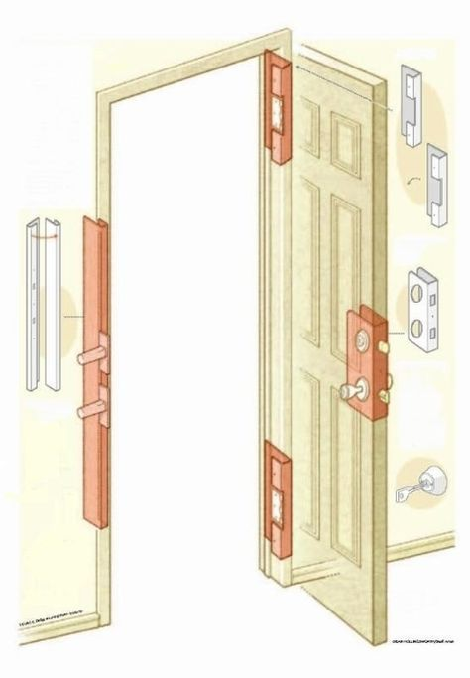
Your first course of action after initiating the escape plan with your code word should be to go immediately to your designated safe room. A safe room is exactly what it sounds like: a room that prioritizes your safety and security.
Your safe room should have a door with a deadbolt, as well as a heavy piece of furniture ready and available to blockade the door with. If you have a home defense firearm and know how to use it effectively, then your safe room should definitely contain one.
Before even thinking about fending off a home invader, however, you need to be thinking about actually escaping the premises so there’s no risk of possibly endangering you or your loved ones. Your safe room should have a window that you can escape out of if the coast is clear. If your home has a second story, your safe room should ideally be on that second story, as the window would be inaccessible to intruders.
If this is your situation, have a rope or a ladder stocked away in your safe room that enables you to get to the ground safely. If your home is a single-story, your safe room’s window should definitely be secure in the case of a home invader trying to gain access through this window. Your safe room’s window should also be covered by curtains or blinds, so as to not give away your hiding place.
No matter what though, when attempting to escape the building, make sure that the coast is 100% clear. You do not want to be vulnerable in a situation like this. After escaping, your next action should be to run to a designated neighbor’s house for safety.
Another thing a safe room should include is a phone—preferably an extra cheap cell phone, so the home invader can’t cut any phone wires. This leads us to our 4th tactical tip for surviving a home invasion.

4. Call/Text the Police
Once you’re in a safe and secure place, you need to call or text (in some situations) the police. The sooner you contact the police, the sooner you’ll not only be safe but have a better chance of catching the home invader as well.
This is where a cell phone over a landline comes in handy. With a cell phone, you’re almost assured the ability to get help, where with a landline there is always that possibility of wires getting cut.

5. Be Smart
If you’re a victim of a home invasion, don’t try to be a hero. Your life is more valuable than any worldly possession you could ever possibly own. You want to avoid confrontation at all costs, but if you do happen to be forced into confronting the home invader, first try to de-escalate the situation and follow their orders and commands.
Most of the time, the home invader doesn’t have any intention of harming anyone. However, if the invader is noticeably aggressive and violent, you need to fight back. Whatever you do, never leave with an intruder to another location. The reason? You’re very unlikely to make it out alive.
You can use intimidation factors to avoid confrontation such as a pump shotgun and/or a bull horn to tell home invaders that you have a gun and have called the police. Know when to use your firearm (if you have one and know how to use it), because when it comes down to it, you need to take action in order to keep yourself safe.

