Summer Heat Waves By Joseph Alton MD

26
Jun
Summer can be cruel to those sensitive to the heat, and it often comes with a vengeance in parts of North America. Record high temperatures have been recorded in many areas, even in already-sunny Florida. Several heat waves are already predicted to wreak havoc before the summer is through.
Areas in the Midwest are susceptible to “heat domes.” A heat dome forms when a persistent, strong high-pressure system parks itself over a specific region. It acts like a giant, stagnant lid over the atmosphere, trapping hot air in place and preventing cloud formation and cooling rain.
This year, it’s even worse in Europe, where only twenty percent of homes have air conditioning, partially on behalf of mitigating climate change. Europeans have historically viewed air conditioning as an expensive, environmentally unfriendly, and unnecessary luxury. High energy costs, older architecture, and other factors are also at play. The end result is hundreds of older Europeans suffering fatal heat-related injuries (also known as “hyperthermia”).
Even in places where the air temperature doesn’t get dangerously high, the “heat index” can reach 110 degrees Fahrenheit. The heat index is a measure of the effects of air temperature combined with high humidity.
WHY HUMIDITY MATTERS
People say “It ain’t the heat, it’s the humidity.” Why does humidity matter? Above 60 percent relative humidity, natural loss of heat by perspiration is impaired; exposure to full sun increases the reported heat index by as much as 10-15 degrees Fahrenheit. All this increases the chances of heat-related illnesses such as heat stroke and heat exhaustion.
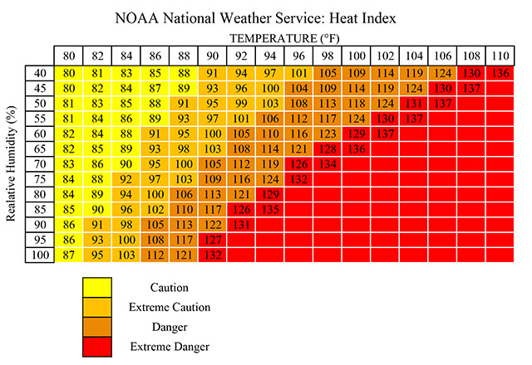
URBAN VS RURAL AREAS
High air temperatures are almost always worse in urban areas due to the Urban Heat Island (UHI) effect. Cities trap and magnify heat, making urban environments significantly hotter “heat islands” than surrounding rural areas. This effect is particularly noticeable at night.
You can expect urban areas to be one to seven degrees Fahrenheit hotter than surrounding countrysides during the day. It’s even worse at night, when urban areas rise to 22 degrees warmer.
WHY CITIES ARE WORSE
Several factors are the cause:
Asphalt and Concrete: Paving absorbs the sun’s energy during the day and releases it slowly at night, keeping cities hot pretty much around the clock.
Lack of Vegetation: Fewer trees and green spaces mean cities miss out on the natural cooling effect of water evaporating from leaves.
Trapped Heat/Poor Airflow: Tall buildings and narrow streets trap solar radiation and block cooling winds.
Human Activity: Industrial activity, large machinery, and dense vehicle traffic continuously emit exhaust and heat directly into the environment.
RURAL FOLKS ALSO AT RISK
While rural areas generally have lower overall temperatures, Heat and Health Index data shows that rural populations can be just as vulnerable to extreme heat. Greater numbers of farm workers and larger distances to medical facilities are major factors.
HEAT WAVES AS NATURAL DISASTERS
You might not consider a heat wave to be a natural disaster, but it most certainly is. Heat waves can cause mass casualties, as they did in Europe when tens of thousands died of exposure (not in the Middle Ages, but in 2003). India, Pakistan, and other underdeveloped tropical countries experience thousands of heat-related deaths yearly.
In the United States, heat wave disasters receive a similar warning system as another natural disaster: hurricanes. Heat notices go as follows:
- Excessive Heat Watch: Conditions are favorable for an excessive heat event in the next 24 to 72 hours.
- Excessive Heat Advisory: Heat Index values are forecasted to reach highs of 100-105 degrees Fahrenheit for the next one to two days.
- Excessive Heat Warning: Heat Index values are expected to meet or exceed 105-110 degrees Fahrenheit for at least two days.
It should be noted that different regions may have their own temperature criteria.
HOW HOT WEATHER KILLS YOU
How exactly does heat kill a person? Your body core regulates its temperature for optimal organ function. When core body temperature rises excessively, this system fails. Inflammation occurs, cells die, and toxins leak. Fatalities can occur very quickly without rapid intervention. Even with modern technology, hyperthermia carries a 10 percent death rate, mostly in the elderly and infirm. Those who are physically fit, however, are not immune.

NOTE: For an article specifically about how to deal with hyperthermia, click here.
PREVENTING HYPERTHERMIA
In heat wave conditions, you have a certain amount of control over whether people develop heat-related emergencies. Certain strategies may save lives:
- Be sure to avoid leaving children or pets in enclosed vehicles.
- Stay hydrated but avoid caffeinated beverages and alcoholic drinks.
- Eat frequently, small meals.
- Wear light-colored, loose-fitting clothing. Avoid heavy fabrics.
- Stay indoors and avoid exertion during the hottest parts of the day.
- Never schedule work sessions in excessive heat. If there is no choice, rest frequently in the shade.
- Check frequently on those who are very young, elderly, and infirm. They are most prone to heat-related illnesses.
- Don’t forget your pets. They are just as susceptible to a heat-related emergency.
In normal times, follow updates from local authorities.

