PART TWO GROWING UP IN THE DEPRESSION

Homemade Toys and Games
Games were simple with the most basic supplies. Marbles were a big deal, and kids played for keeps, carried their favorites in a cloth bag, and negotiated trades with the intensity of Wall Street brokers. A good marble collection was something to be proud of.
“I’ll trade you these two cat’s-eyes for one of your steelies.”
Tops, hoops, jump rope, pickup sticks, and jacks — couldn’t get any simpler than those. Dolls could be made from corn husks or scraps of fabric, and a store-bought doll was an unbelievable luxury. Slingshots, BB guns, and walking the rails — there were plenty of opportunities for serious injuries! None of it cost anything but without fancy or expensive must-have toys and games, the emphasis was on the experience and countless hours spent with friends.
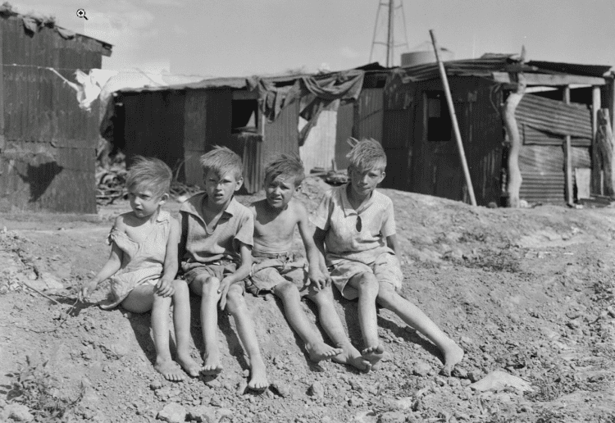
The Radio
The radio was the great equalizer of Depression-era America. Families from every walk of life gathered around it in the evenings the way families now gather around a television. Kids listened to serial dramas, comedies, and music. Jack Benny, The Lone Ranger– my Dad loved Fibber McGee and Molly. These characters were as beloved as any major celebrity is today.
Chester Myers’ family in New Mexico had welded a giant antenna to their blacksmith shop to pull in two stations, one from Denver and one from Mexico. All the men in the neighborhood would gather at the shop to listen, especially to the prize fights. In a place that remote, a radio was a lifeline to the wider world, and an entire community would build its evenings around it, and then talk about it the next day.
Bob, who grew up in rural Texas, remembered his grandparents’ evenings the same way. His grandfather came in from the oilfield, supper was on the table, and after the meal a battery-powered radio brought in the evening news and the Grand Ole Opry. That, he says, was real entertainment.
Listening to radio required something television never did — imagination. Kids pictured the stories in their heads, invented the faces and the settings. The music swayed their emotions, and the storylines held their imaginations for weeks and months at a time. Today we would call this “cognitive development.” Back then, it was just a fun way to spend an evening.

Going to the Movies
Then, Hollywood discovered it could turn a profit, entertain, and distract millions of Americans from their dire circumstances all at the same time. A dime could get you into a double feature where you could watch a short Laurel and Hardy flick, then a newsreel, and sometimes a cartoon. For Depression-era kids, the Saturday matinee was an event. It was something they worked towards, saved money for, anticipated, and talked about for days afterward. For a few cents they could escape into a world of color, glamour, and adventure.

Making Things/Learning Skills
In a Depressions-era household, work often became fun. You could do something productive, maybe learn a new skill, and have fun all at the same time, like making fudge on a cold afternoon or patching a quilt with your grandmother. These didn’t seem like “work” at all.
Gina Gould put it plainly when she told me about the men in her family who had lived through those years. With no television, no money, but with lots of time on their hands, it meant people became inventors and discovered talents they didn’t know they had. Her uncle and father built cars from scratch and actually invented farm equipment. They played any instrument you put in front of them. My own great-aunts could play multiple instruments and formed a singing group that traveled around from church to church.
So when Depression-era kids had time on their hands but no money, they got creative in ways that our modern-day kids and grandkids rarely get a chance to.

What All This Built In Them
Read through enough first-hand stories from the Great Depression, and a few things stand out, mostly the lifelong effects, positive effects, those years had on people. There’s so much wisdom to be learned from them.
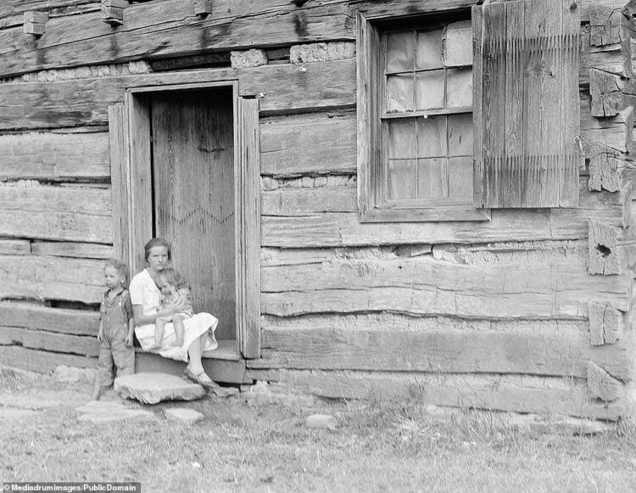
Competence. They knew how to do things — like, everything! They learned real, physical, practical skills they could use every day. From the earliest ages, they learned how to feed themselves, clothe themselves, fix things, grow things, and even invent things. When a child becomes competent in any skill, their confidence grows, and this is something a classroom doesn’t give you.
Thrift as a virtue, not a hardship. Depression-era survivors didn’t experience frugality as deprivation. Instead, of a throwaway mentality, they really did, “Use it up, wear it out, make it do, or do without.” Gordon Peterson’s mother saved every leftover, no matter how small. Even a spoonful of vegetables went into the refrigerator. Every Tuesday she cooked up everything that had accumulated during the week — cooked vegetables, bits of pork and chicken, and even leftover soup or a casserole — then went shopping Wednesday morning. He couldn’t remember her ever throwing out spoiled food, because she simply didn’t let it get that far.
Kate Redden grew up in a New York household where aluminum foil was finger-pressed flat and reused, brown paper bags became garbage bags or book covers, and worn-out clothes became rags. When the rags wore out, they were cut into strips, braided together, and sewn into rugs. Nothing left that house without being used up completely.
Delayed gratification. The Saturday movie matinee was special because you saved and waited for it. Strawberries in June were extra special because there were no strawberries in February, unless you had used last summer’s batch to make jam.
Lynn Vielbaum’s husband Frank had watched his family get evicted and spend a night on the sidewalk surrounded by piles of everything they owned. For the rest of his life he never went into debt, putting off purchases until he was certain he had the money to pay cash, in full. This wasn’t because he was a miser. In fact, at his memorial service, when the speaker mentioned how thrifty Frank was, the whole room laughed, because they all knew Frank. He had learned the way to avoid ever sleeping on the sidewalk again was to delay wants, save and budget for them, and then enjoy the purchase without any regrets.
Family identity. When you work together toward the same goal, like filling the root cellar with crops you pulled from the ground together, you become part of something bigger than just yourself. Dan, a Midwesterner who grew up hearing Depression stories from every branch of his family, described how his grandfather’s family had a once-a-month “depression food” meal together — beans and cornbread, rabbit or squirrel, potatoes, oak leaf tea, chicory coffee, and vinegar pie for dessert.
His grandfather started each of those meals with a prayer of thankfulness and closed it with, “May we never forget.“ When the meal was done, the family spent hours around the table just talking — about problems, joys, and how the family managed the challenges of that day and time. And they were deliberate about remembering. They wanted their kids and grandkids to know where they came from and what their people were made of. That’s how a family forms an identity.
Neighborliness
Carol’s grandmother was born in 1900 and lived to be 96. On her 92nd birthday, someone asked her what she considered her best years. Her answer: the Great Depression, and her reasoning made sense. Nobody was better than anyone else or looked down on someone because they had less. They all pulled together to survive, the whole neighborhood.
She described block dinners where every family brought whatever they could — a cooked vegetable, a loaf of bread, a dish of some sort (my Nana would have brought her Shlumgum), and the whole community made sure every family on the street had a hot meal that night. When someone was sick or a baby was due, the neighborhood showed up.
This is hardly the experience in most neighborhoods today. Carol commented that she doesn’t even know her neighbors anymore. People want to be left alone, and neighborliness has become more and more rare.
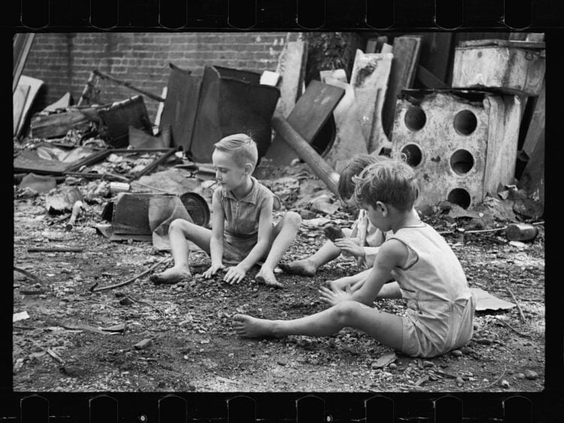
Resilience This was a natural and predictable result of experiencing and learning things the hard way. Nobody sat down and taught these kids, “Here’s how to be resilient.” They naturally learned this by getting through hard times the only way you can — by getting up every single morning and doing what has to be done.

What We Can Take From This
You don’t have to manufacture your own Great Depression experience at home to give your kids some of what those kids had. The research on this is pretty clear. Kids who do real household work, tasks that are significant, not “busy work”, and contribute to the family and household in a significant way, grow up more confident, more capable in handling life’s ups and downs.
They also grow up knowing all the practical things, like how to cook, do laundry, grow a garden, and manage their own money. Astonishingly, there are a lot of adults who lack these basic skills!
The use it up, wear it out, make it do, or do without mindset didn’t make Depression-era kids miserable. It made them resourceful. There’s a reason people who lived through those years are often described by their own kids and grandkids with awe. They could do things. They knew things, and they didn’t panic when life got hard.
We can choose to raise our kids the same way. Not because we’re headed into hard times, although that’s worth thinking about, but because capable kids become capable adults. Confident kids who make smart decisions become adults, trained and ready to do the same.
So, give them a little plot of their own in the backyard and a few vegetable seeds to sow. Ask them to make dessert for the family, and if they mess up, let them try again. Give them some real responsibility and then step back. I think they’ll surprise you, and more importantly, they’ll surprise themselves.

