PART ONE

Growing Up During the Great Depression: What Kids Did and Why It Mattered
By Lisa Bedford / May 29, 2026 / 7 Comments
Ask anyone whose parents or grandparents lived through the Great Depression and you’ll hear a version of the same thing: those people were different. They were tougher, more resourceful, and they knew how to do everything.
What made them that way? Well, a lot it starts with what happened to them as kids.
Nobody in a Depression-era household got a free ride. Not the adults, not the teenagers, and not the kids. From the time they were old enough to be useful, they were expected to contribute, and they did.

Life Was Different Before It Got Hard
Before the crash of 1929, most American families, especially rural ones, already expected children to actively take on chores and responsibilities. Farm families had always depended on everyone doing this, but when the Great Depression hit, this became even more important to the family’s survival. Families who had been comfortable suddenly weren’t as hundreds of thousands of fathers lost jobs. By 1933, a third of all farmers had lost their land, and one in four workers was unemployed at the peak of the crisis.
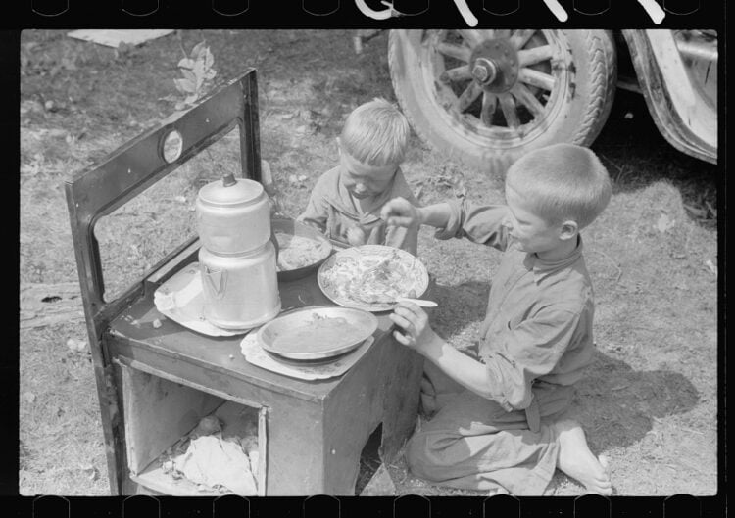
Kids pick up on things, especially when parents are stressed and worried. They could see it in the empty pantry, the meager dinners, and in their parents’ faces. By far, most responded in the same way their parents did. They stepped up and did whatever had to be done.

What the Little Ones Did (Ages 4–7
Even the youngest children had jobs — real jobs (or tasks) that were more than just busy work. They were helpful and important contributions to the household.
By age four or five, children were gathering eggs, bringing in buckets of water from a well, carrying small loads of wood, and running errands to neighbors or the corner store. A four-year-old can carry eggs without breaking them. A five-year-old can pick green beans for an hour if she understands why it matters.
My Nana told us stories of her step-dad coming home from work, handing her a small bucket, and sending her down the street to the pub for a bucket of beer! She was just six years-old at the time! An essential household task? Apparently it was, for him.
Kids this age also watched younger siblings, sometimes for hours at a time while parents worked. There were no playdates, no schedule full of “enrichment” activities. If there was a baby and an older child, the older child was often put in charge of the baby and younger siblings.
Small children also helped with the constant sorting and salvaging that Depression-era households required. Remember, nothing could be wasted. They pulled nails out of scrap wood so they could be reused. They untangled and rolled up string and picked through dried beans, looking for tiny stones before the beans went in the cooking pot. For the little ones, this was useful work that taught small hands to do careful and patient work.
The smallest chores had a way of becoming some of the most enduring memories. One woman, whose mother grew up on a farm in rural Oregon, described how her mother’s first household job as a very young child was drying the silverware after her grandmother washed dishes. She would spread the pieces out on a chair near the stove and carefully wipe and put away every single one. That little girl grew up to run an entire household’s cooking, baking, sewing, and food preservation before she was a teenager because someone had started her young and taught her to do it right.
For some Depression-era children, “young” meant very young, younger than we might consider to be capable today. In households where older children were out working or going to school and moms were stretched thin, even a five or six-year-old might be handed a baby and told to watch. There was no pondering whether they felt ready or not. The need was there, the child was there, and that was that.
Looking back, it’s impressive how rarely the people who lived this way describe it as deprivation. More often, there’s something almost wistful in the stories they told me — a recognition of being needed and valued from an early age.

The Middle Years: When Kids Became Real Contributors (Ages 8–12)
This is where Depression-era childhood gets even more interesting, with children in this age group barely experiencing an actual childhood, as we would define one today.
By eight or nine, they were expected to cook basic meals from their pantry, tend the family garden from planting through harvest, care for livestock, and do laundry, which meant hauling water, heating it, scrubbing on a washboard, wringing clothes by hand, and hanging them to dry. I’ve done this myself, and it’s an all-day project, not to mention back-breaking.
Girls were taught to sew, mend, and patch almost as soon as they could hold a needle. A pair of pants with a worn-out knee wasn’t thrown away or given to charity. It was patched, then patched again, handed down to be worn by younger siblings, and then the fabric was eventually cut up for quilt squares or some other use.
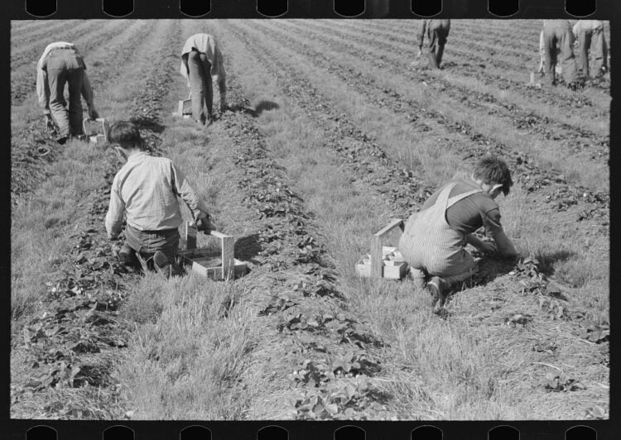
The family garden required non-stop effort, nearly year-round, and the natural source of labor were the kids. Families grew as much food as they possibly could, and kids planted seeds, pulled weeds, watered, watched for pests, and then helped pick and preserve the harvest. One man told me that he could still remember the cracking sound made by big, green grasshoppers as his grandma snapped them in two!
Linda Morgan, who grew up hearing her Depression-era parents’ stories, described her mother’s childhood in rural Oregon this way: from around age seven, her mother and her sister baked a full batch of bread every single day. They handled most of the household cooking and chores mostly because their grandmother was often ill and someone had to do it.
Canning required the whole family to get involved, and children were put to work on it from an early age. Washing and sanitizing jars, snapping beans, peeling peaches, carrying bushels — there was no end to the work involved every late summer and early fall. The canning season was exhausting, hot, and could last for weeks, but from emails sent to me from readers, it was one of the great, shared memories of their childhoods. There was something about working together toward a goal everyone participated in and then could see the results as shelves filled up with colorful jars of jams, pickles, and that season’s harvest.
Some kids took on responsibilities that might deter many adults today. Chester Myers, who grew up near the Navajo reservation in New Mexico, started getting up at 4 a.m. to hunt, fish, or set animal traps before school at age nine. When asked years later why he did it every day, even on school days, his answer was simple: if he didn’t go out, the family wouldn’t have meat that day. On mornings when the hunt came up empty, they ate beans and cornbread.
Carol Jackson’s father took a different approach to the food problem. He foraged. His own father taught him to pick blackberries, collect black walnuts, and identify edible greens, like dandelions, chickweed, and others, that could be cooked like spinach. He walked along the railroad tracks near their home picking up pieces of coal that had fallen from passing trains. Those went into the stove that heated the house. He knew which plants the caterpillars loved, and could almost always find a worm in the stem to use as fishing bait.
This wasn’t just a way to spend time or explore nature, and these weren’t hobbies. They were skills his family depended on, passed from father to son because the alternative was going without, and going hungry.

Earning Money
By ten or eleven, many children were busy earning money. It became not only a part-time job but a way to learn and build skills, too. Boys sold newspapers on corners, shined shoes, or did yard work for neighbors who still had a bit of money to spare. Girls took in mending, helped with other families’ washing, and sold garden produce and home-baked goods door to door.
Chester Myers saved an entire year’s worth of trapped beaver pelts and brought them to the local Trading Post. The money he made went toward buying his older sister a purse she had wanted for Christmas. He was proud he could be the one to give her that special gift and equally proud that his family had come to count on him for food.
The important part about children’s earnings in this era is that the money rarely belonged to the child. It went to the family, and that was accepted and understood. A twelve-year-old who handed over his week’s wages to his mother learned about personal sacrifice and interdependence. These kids grew up very quickly — their childhoods weren’t nearly as carefree and self-centered as is the case for many kids today.
One of my readers, Shirley, told me about her mom’s creative way to earn money. She took her broken crayons, the ones too small to draw with, and carved tiny high-heel shoes out of them. Then she sold them to the boarders who rented rooms in their home and saved every penny she made so she could go to a movie or buy ice cream.
My husband’s Uncle Marvin left home in West Texas at the ripe old age of ten. He decided to live the life of a hobo and road the trains as far as Washington state. He must have seen the long line of teenage boys and men standing in line each day for hours in hopes of getting a job like digging ditches, and decided that wasn’t for him.

Teenagers: Near-Adult Responsibility
If kids as young as 4 or 5 were helping to share the family’s load of work and responsibility, then teenagers were more or less adults in every way that mattered.
Often, it was the boys who left school to take full-time jobs and contribute money to their families. Girls ran households when moms were sick, taking on extra jobs, such as doing laundry for wealthier families or working full-time jobs as long as they could. Some families had to split up temporarily, sometimes sending children to live with relatives who could feed them when staying at home could lead to outright starvation.
The Civilian Conservation Corps started in 1933 and employed young men between 18 and 25, but the effects trickled down through families in many ways other than money sent back home. When an older brother left to work for the CCC, his responsibilities fell to the next in line. In a lot of households, seventeen became the new adult age, and often, even younger than that.
Kathy Griffin’s father grew up in Columbus, Georgia, where the main employer was the cotton mill. His own father, damaged by a mustard gas attack in World War I, couldn’t work there because he couldn’t handle the dust. The family survived mostly on catfish her grandfather caught. When her father was fifteen, in 1939, he lied about his age to join the Army. His motivation was simple. In the Army he could count on three meals a day, and it wasn’t going to be catfish! It took his stepmother years to convince him to eat catfish again, or even go fishing.
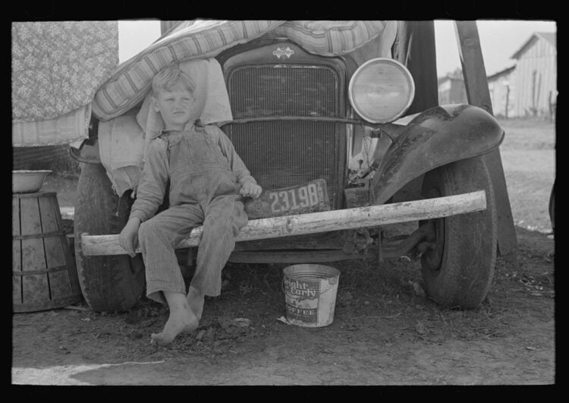
Darlene Ertzberger’s father had a different kind of abrupt ending to his childhood. His family lost their Arkansas farm during the Depression. They loaded everything they could onto a wagon and headed west with no particular destination in mind. They picked crops in Texas, then California, then Oregon, where her grandmother finally said, this is where we stay. Her father was in the eighth grade when he quit school to go to work and help support the family. His own father then abandoned them, leaving her grandmother to hold everything together alone.
What strikes Ertzberger, looking back, is not the hardship but what it produced. All of those children grew into hard workers, capable adults, and kind people. The men had a deep respect for women, and they showed that by always standing up when a woman entered the room. They demonstrated integrity and respect for the rest of their lives. Hard times, she wrote, are not necessarily bad.
Moving so quickly from childhood to a teen with adult responsibilities isn’t ideal, of course. The stories we’ve been told from those years don’t pretend to be otherwise. What’s striking, though, is how rarely Depression survivors describe those years with bitterness. More often their voices are filled with pride. They survived one of the most difficult era in American history. When it really mattered, they stepped up and showed they were willing and able to take on the challenge.

What They Did for Fun
Here’s what surprises a lot of people. Depression-era kids had a lot of fun, not despite their circumstances, but often because of them. More than one person told me how much they enjoyed those years.
In spite of working hard, there was still free time, and when you can’t buy entertainment, you invent it. Turns out, kids are incredibly good at inventing all kinds of ways to stay entertained and have fun.

Outdoor Play — All Day, Unsupervised
Regardless of where they lived, kids roamed. They roamed around their neighborhoods, nearby fields, creeks, and woods. They built forts, dammed up streams, caught crawfish and lightning bugs, organized games of kick the can and hide-and-seek for the whole neighborhood that went on until dark. They spent most of their free time outdoors.

Local swimming holes, if you were lucky enough to live near one, were the summer social center for rural kids. And, they were on their own with no supervision, no lifeguards, and no formal swimming lessons. Kids who couldn’t swim learned from the kids who could, and if they got hurt, they dealt with it, and kept swimming or exploring.

